Larry Herring

Salim Almenshad

ECE546

10-12-20

Lab2

Question1:

Schematics1

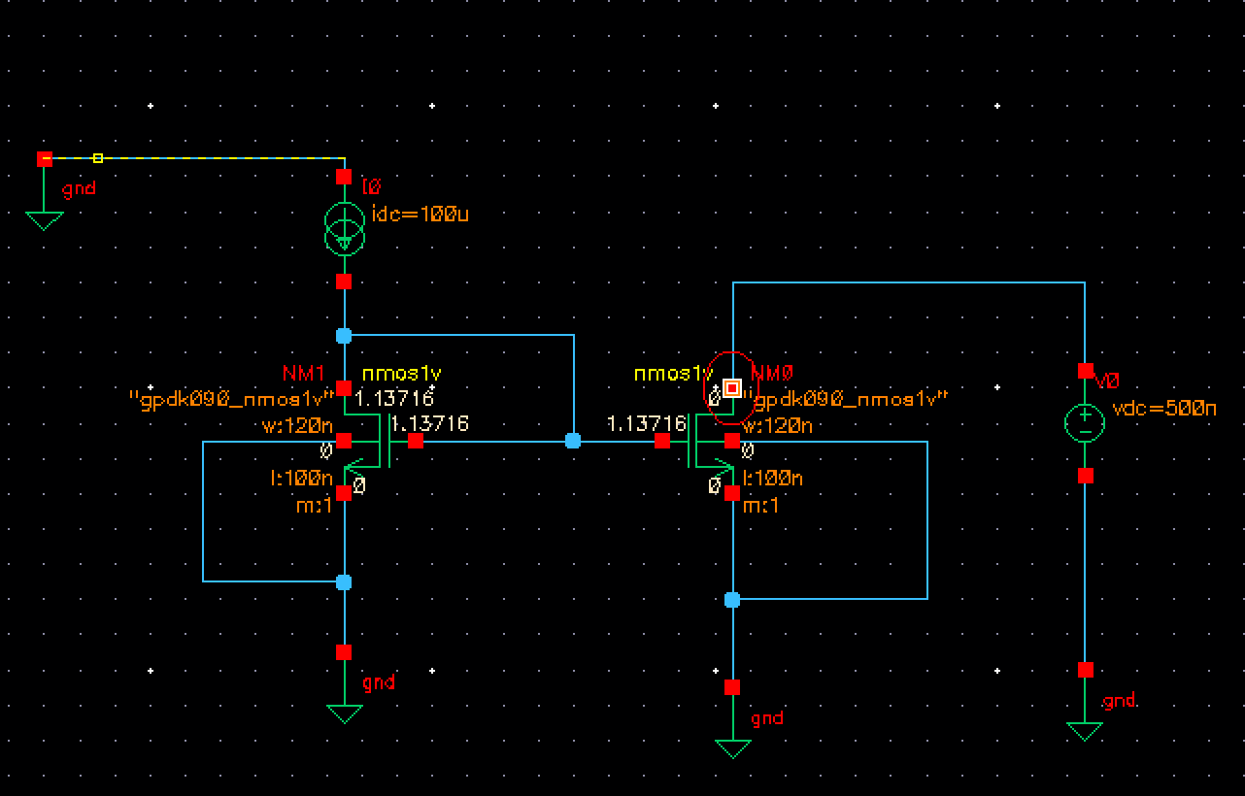

DC respond of nmos1v as mentioned

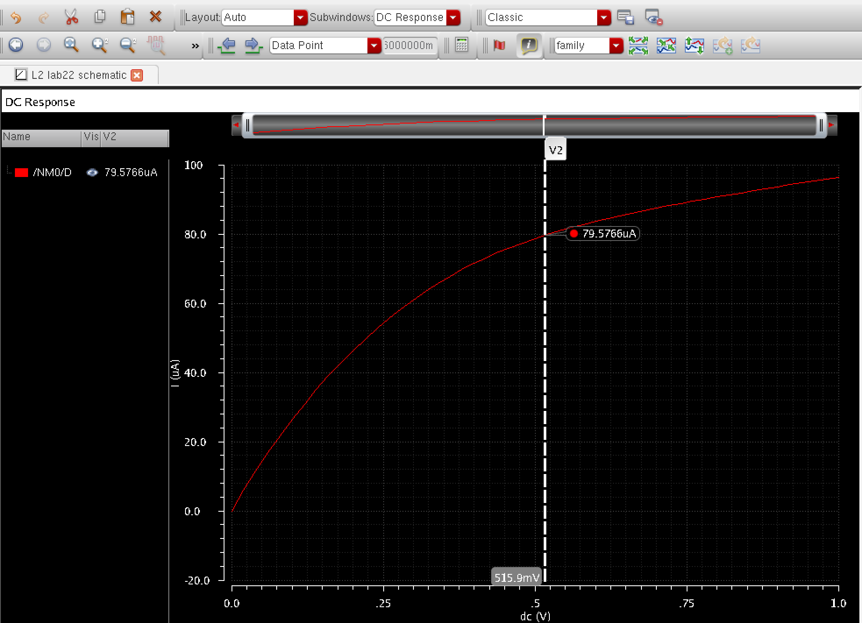

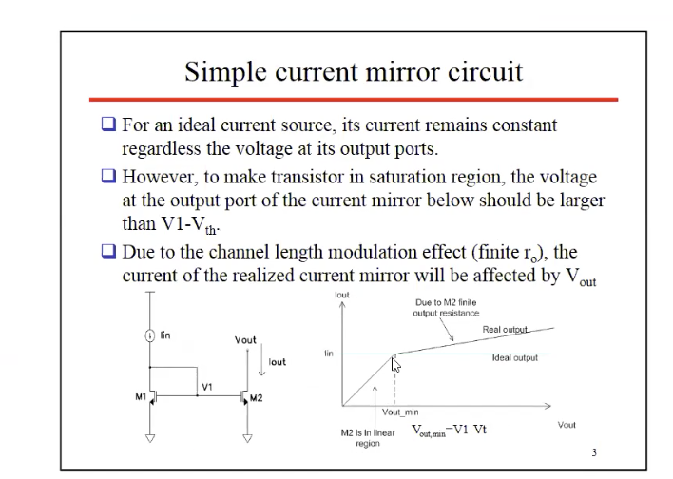

Slope of the current

To find the slope, we took 2 points from the figure below and applied the slop formula to find the slope of the current.

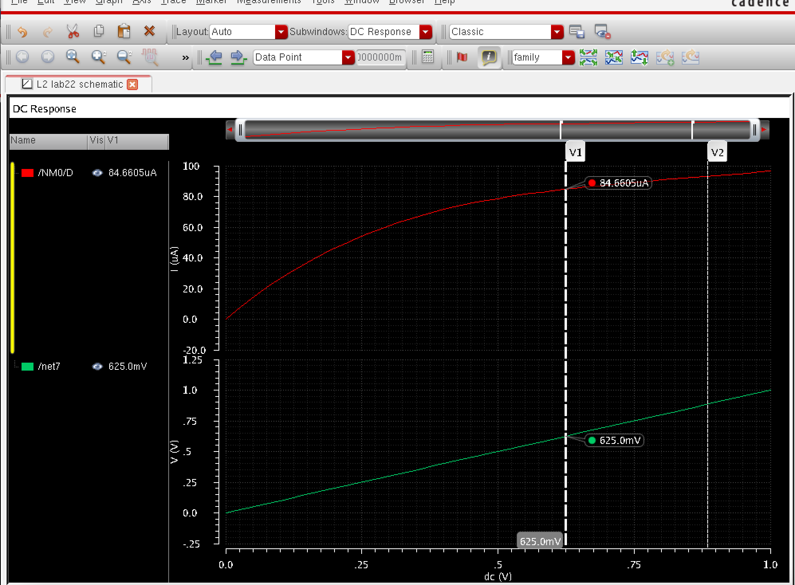

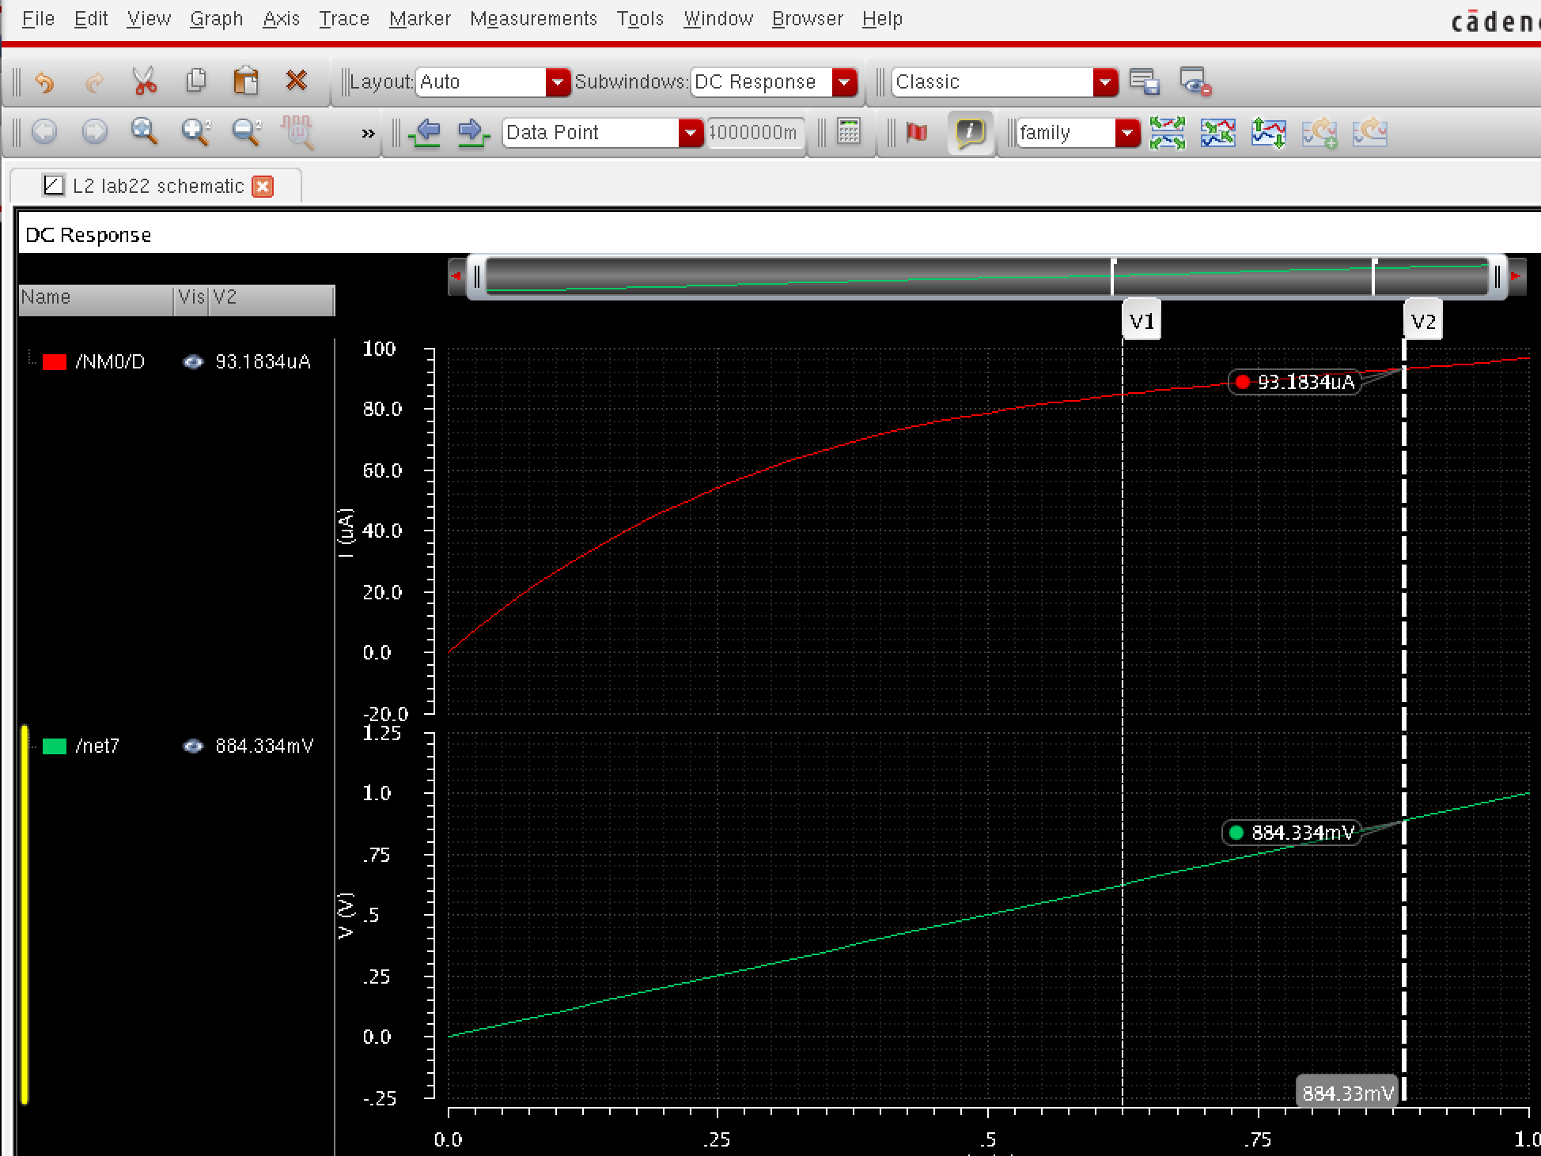

Output resistance (V2-v1)/(i2-i1)=30.4k ohm

Question 2.

DC response to nmos1v

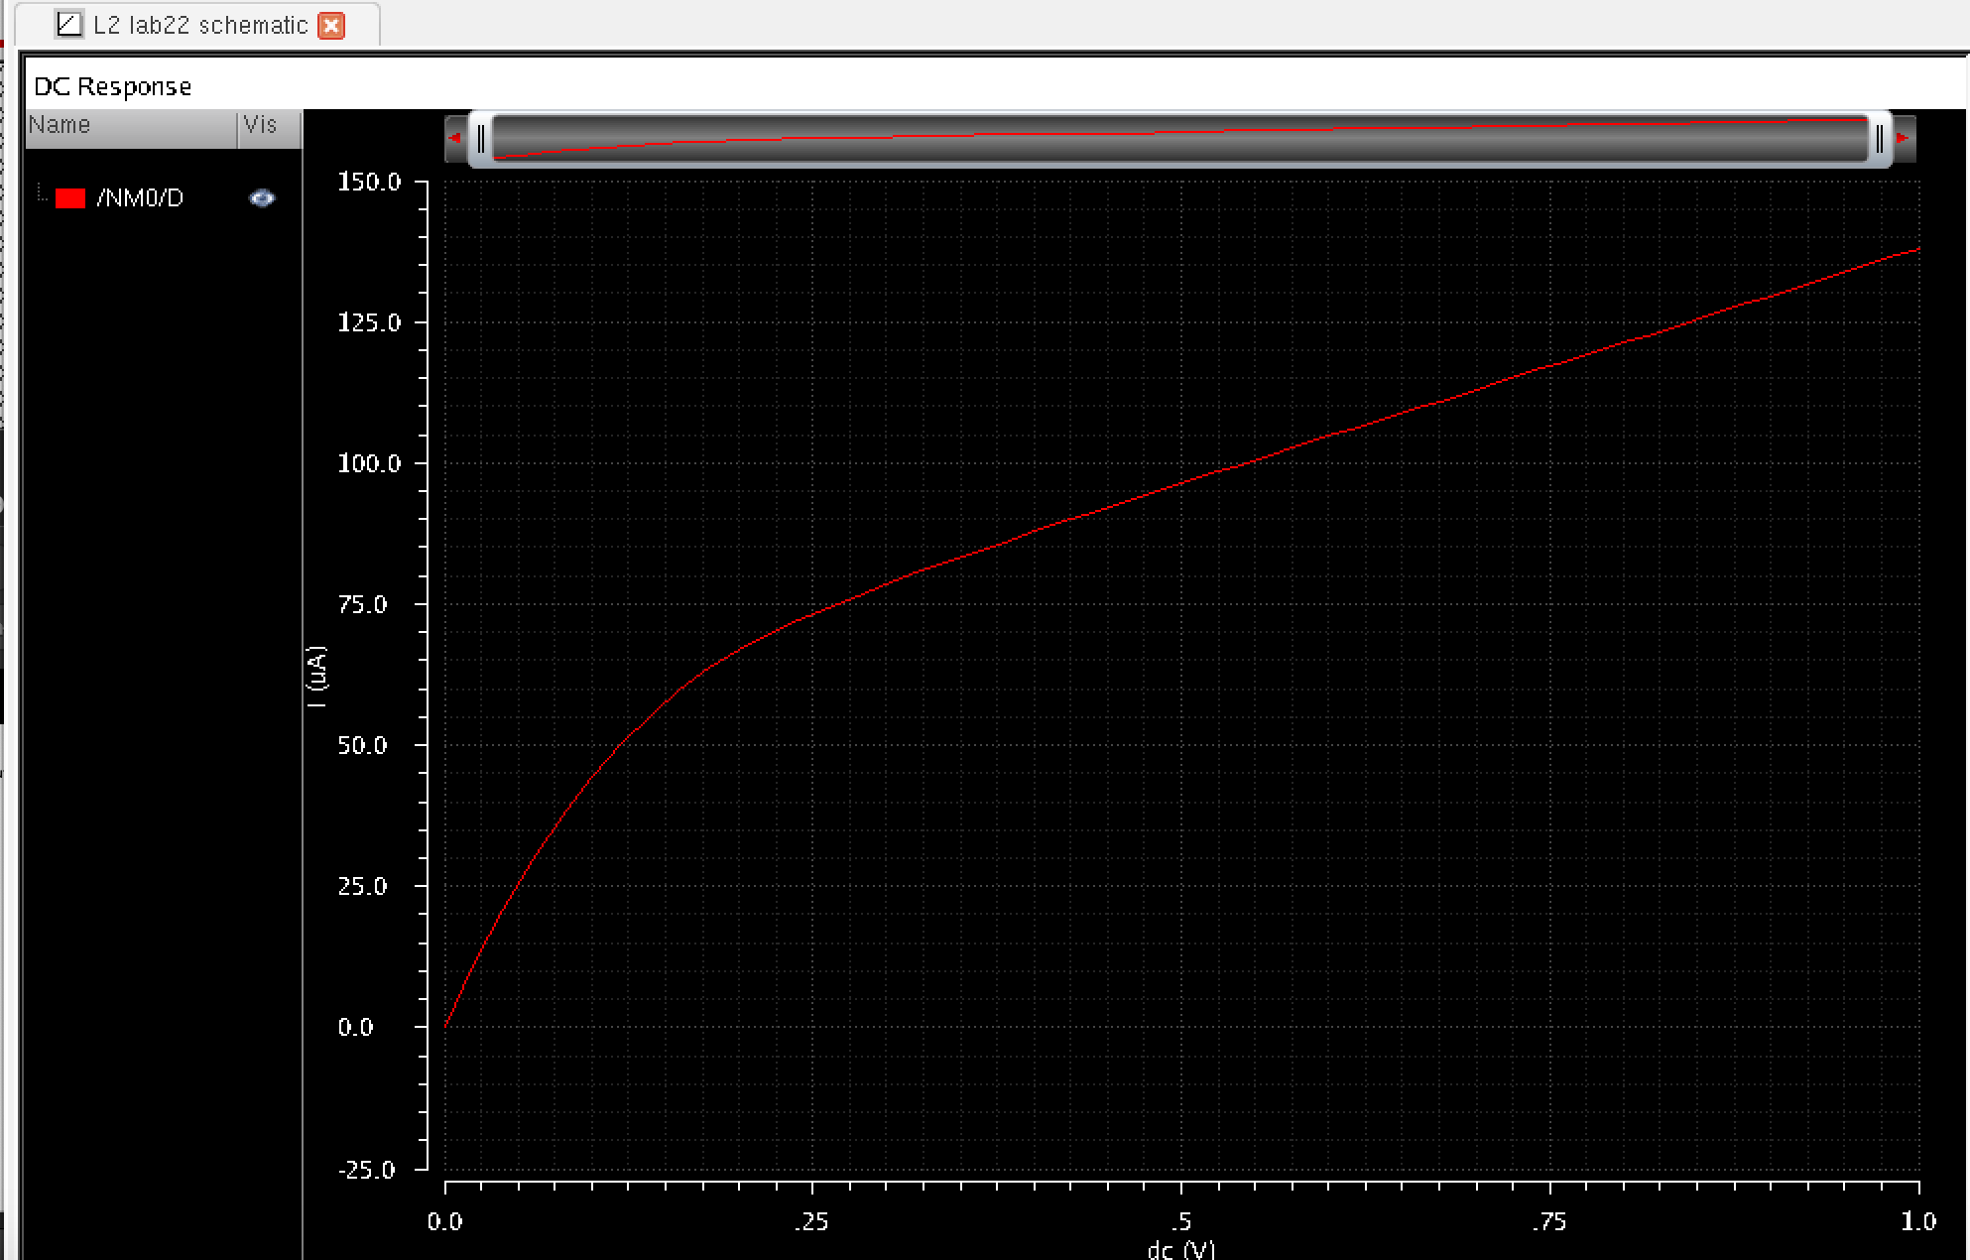

The slope of the dc response for v1

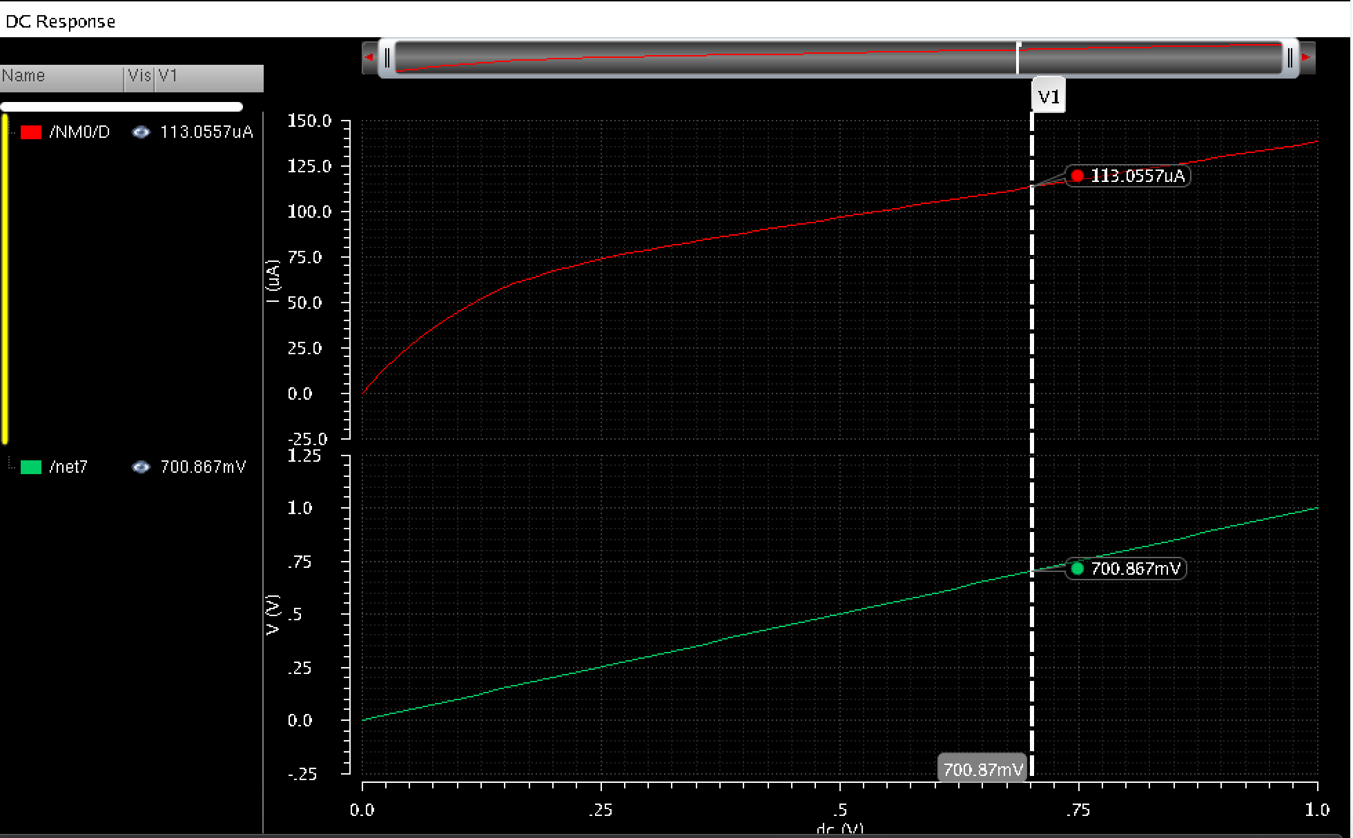

Slope of v1 and v2 from both transistors

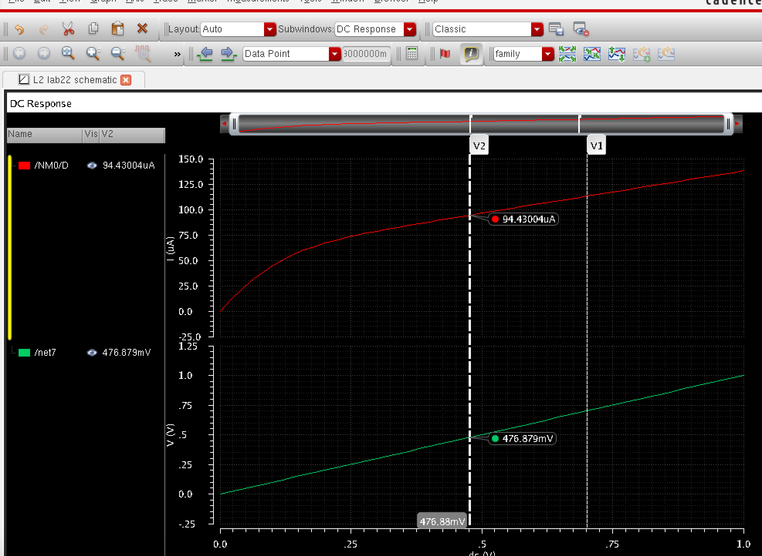

Conclusion: By changing both transistors to 0.6u N and applying the DC sweep, the slope of the dc response decreases from figure 1.

Question3.

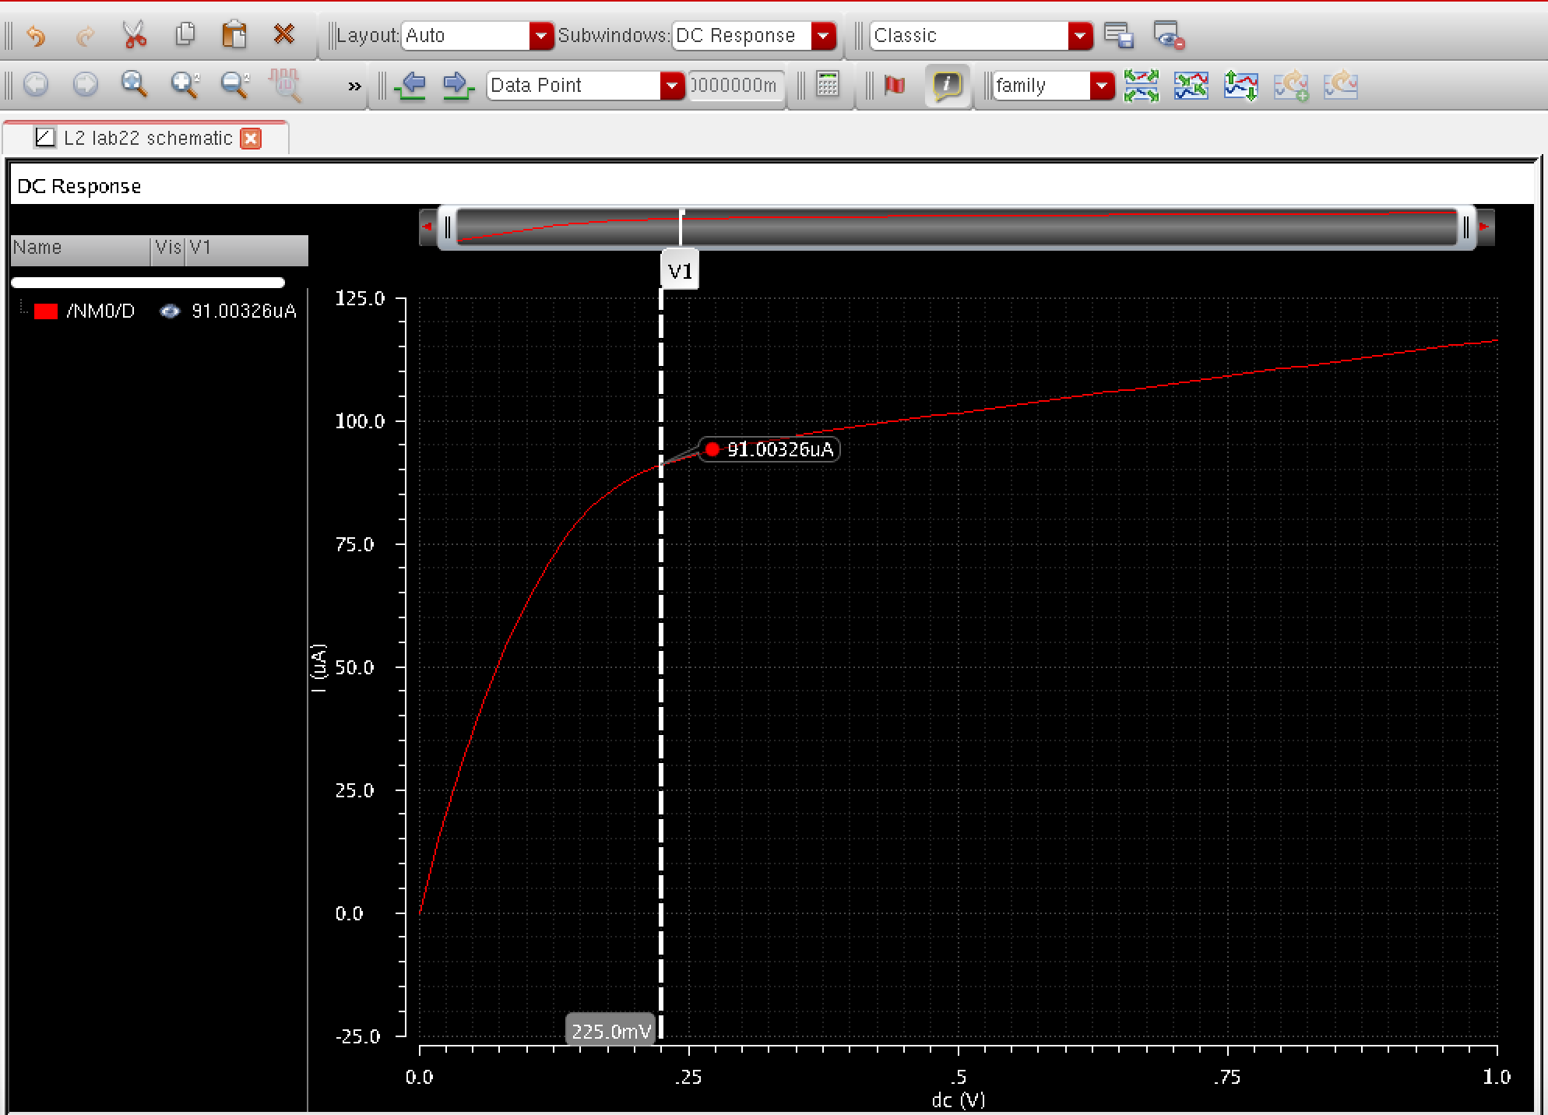

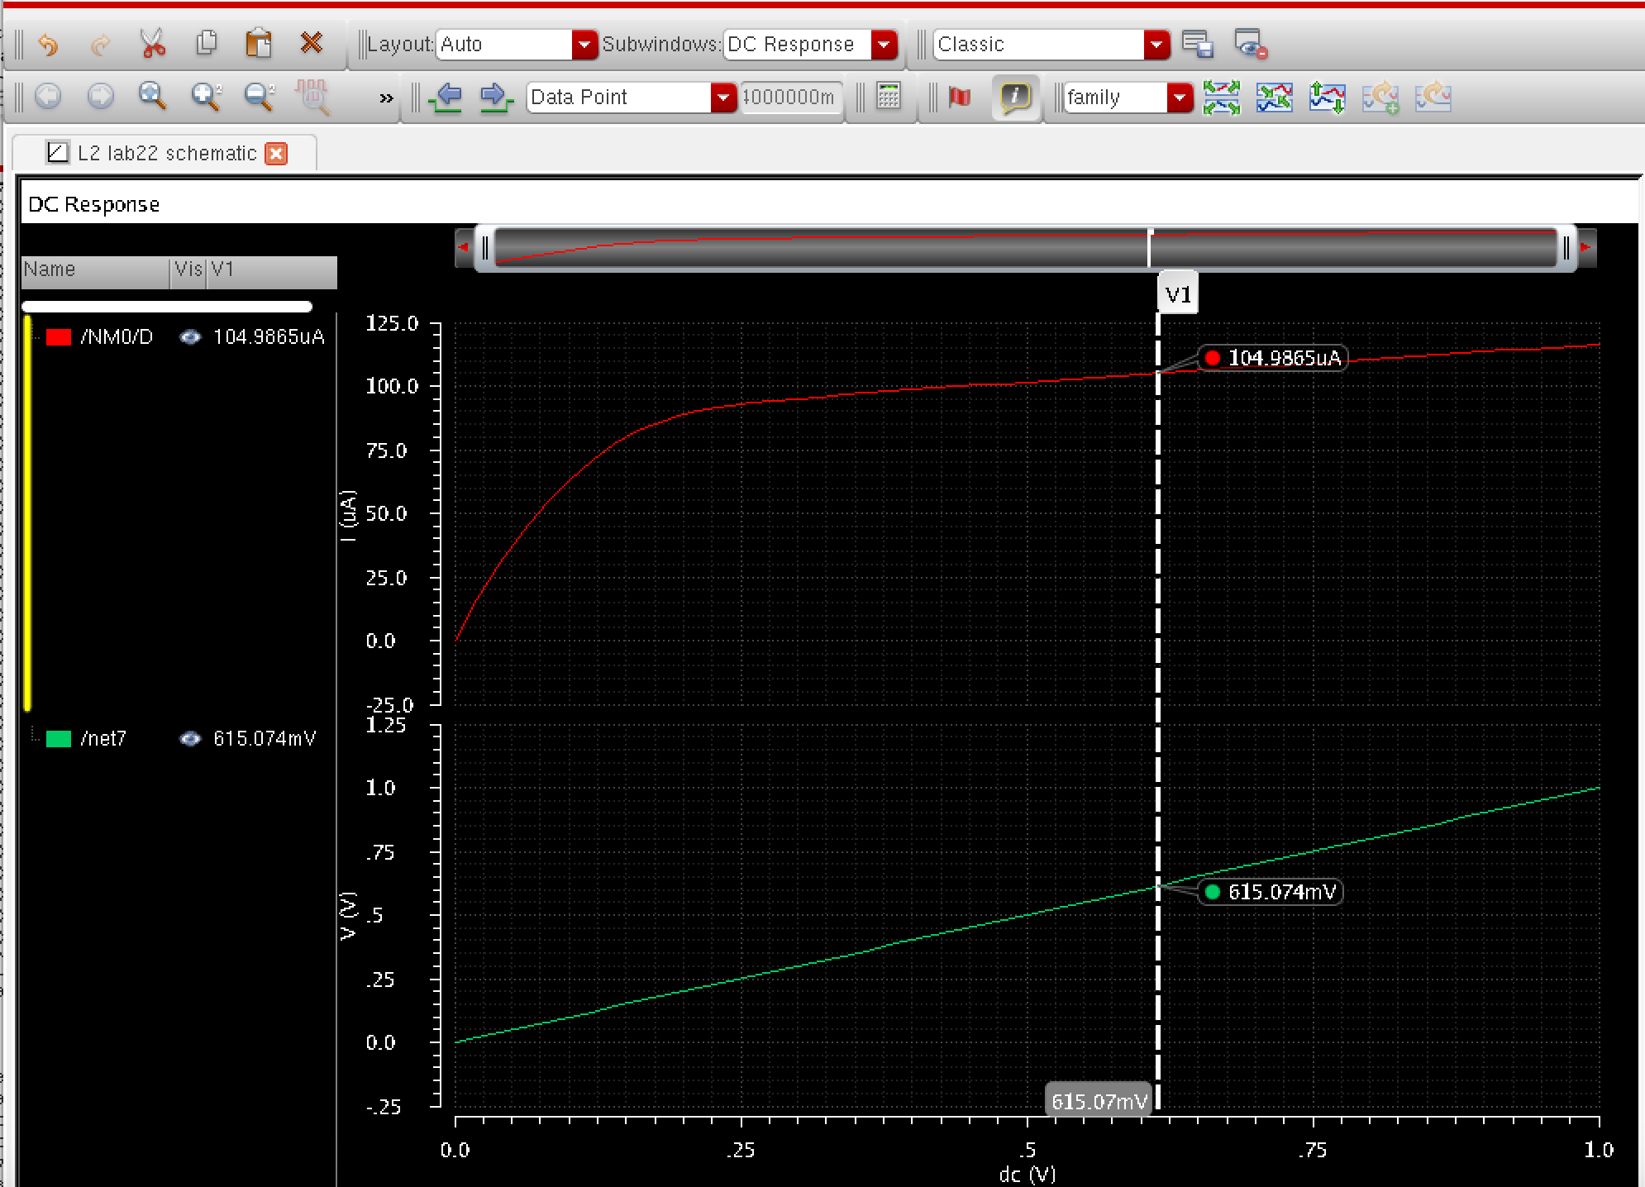

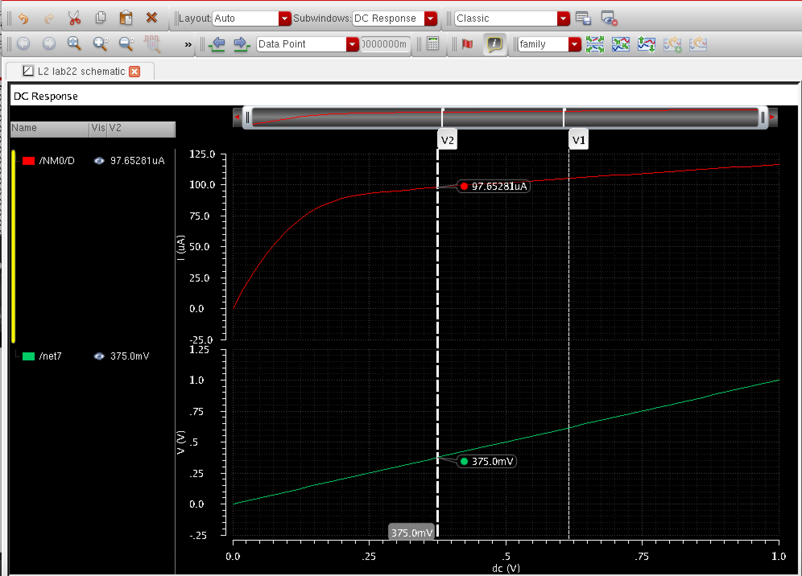

To find the slope of the voltage and the current, we needed to find the resistance.

Conclusion: The slope of nmosv1 increases dramatically by a steep slope when both transistors are changed to 3.6u compared to figure1.

Question4.

Schematic 2 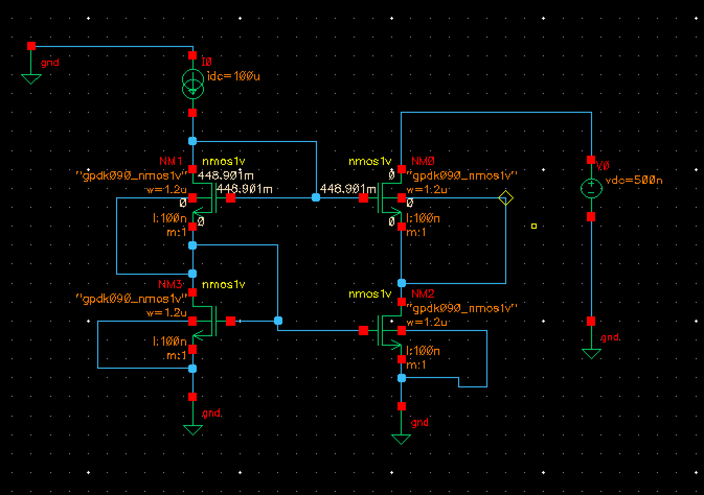

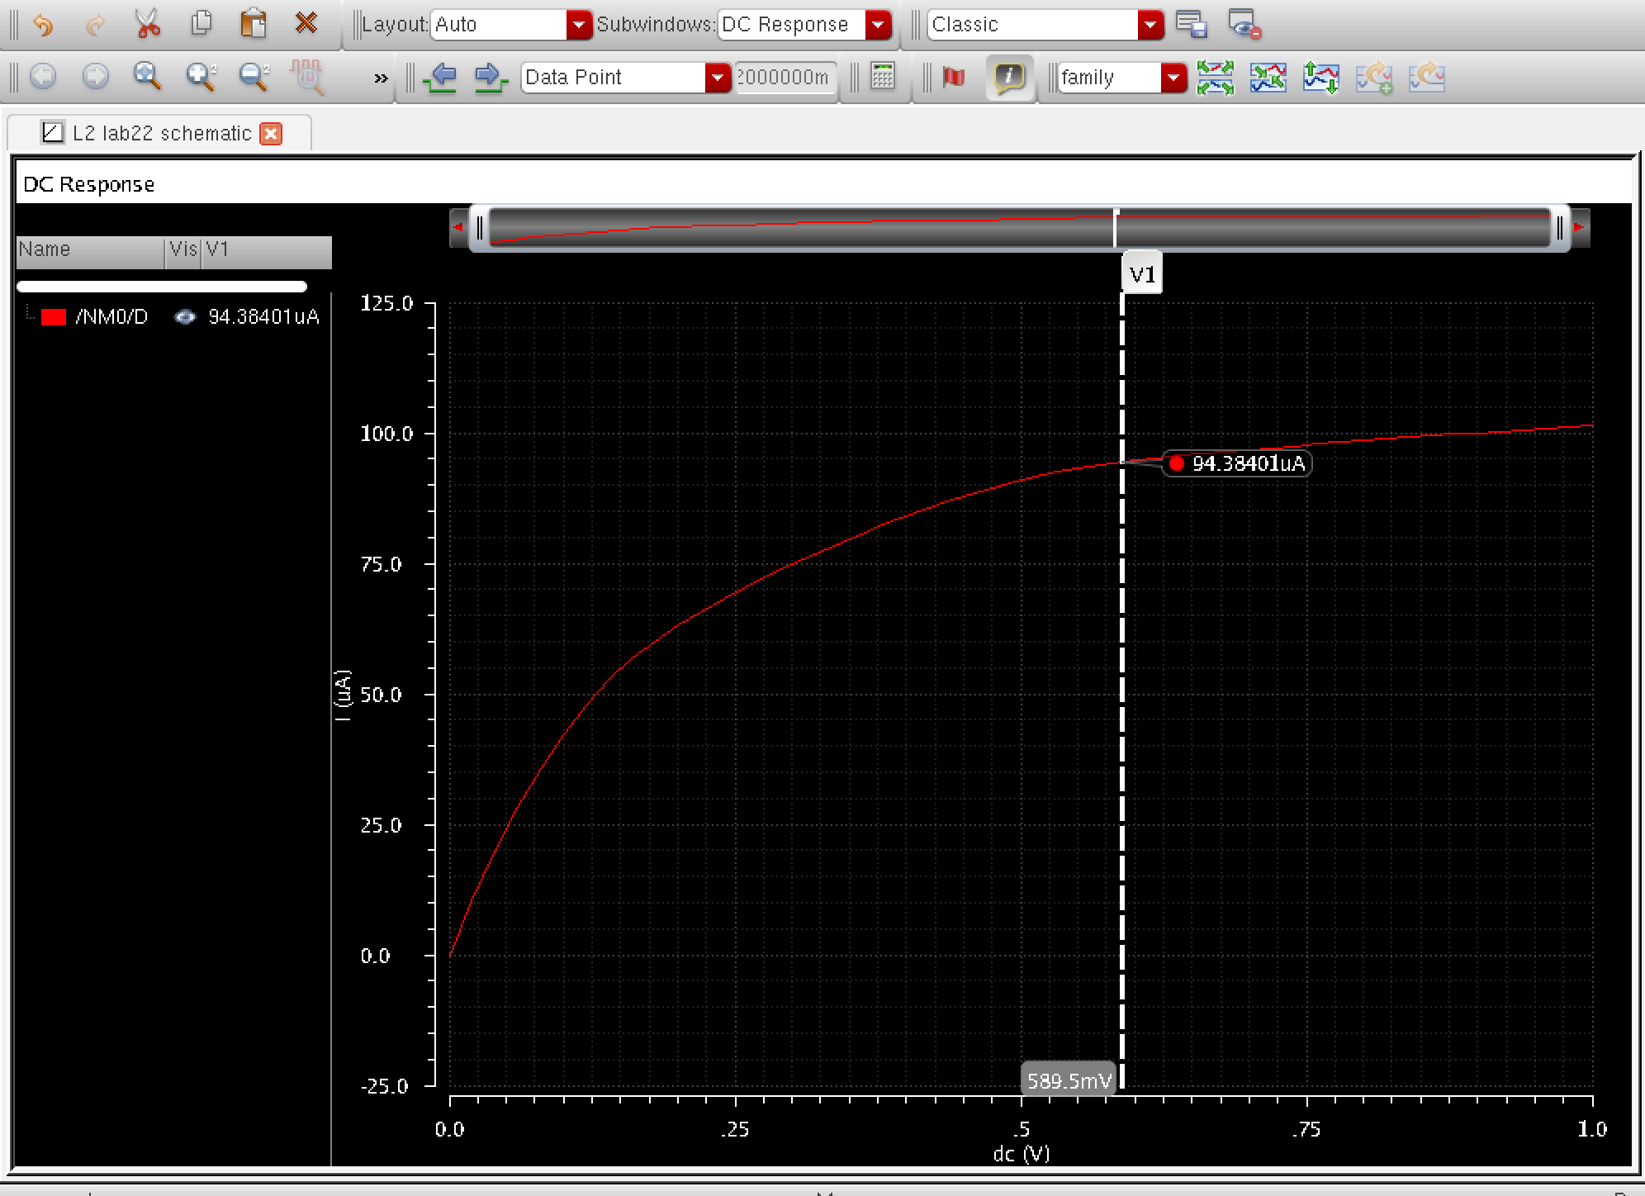

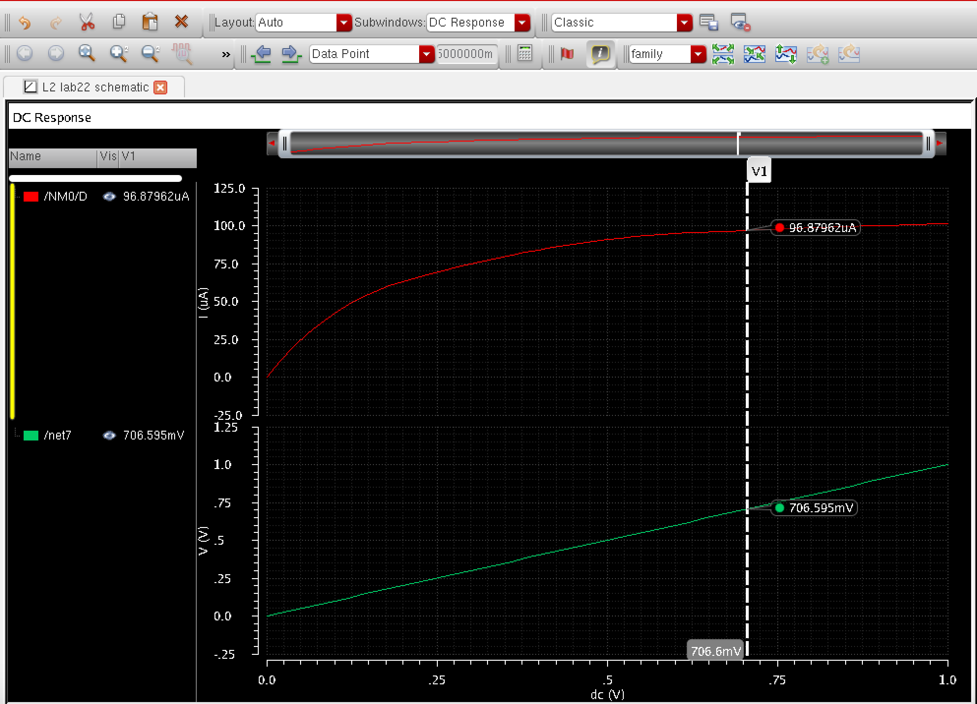

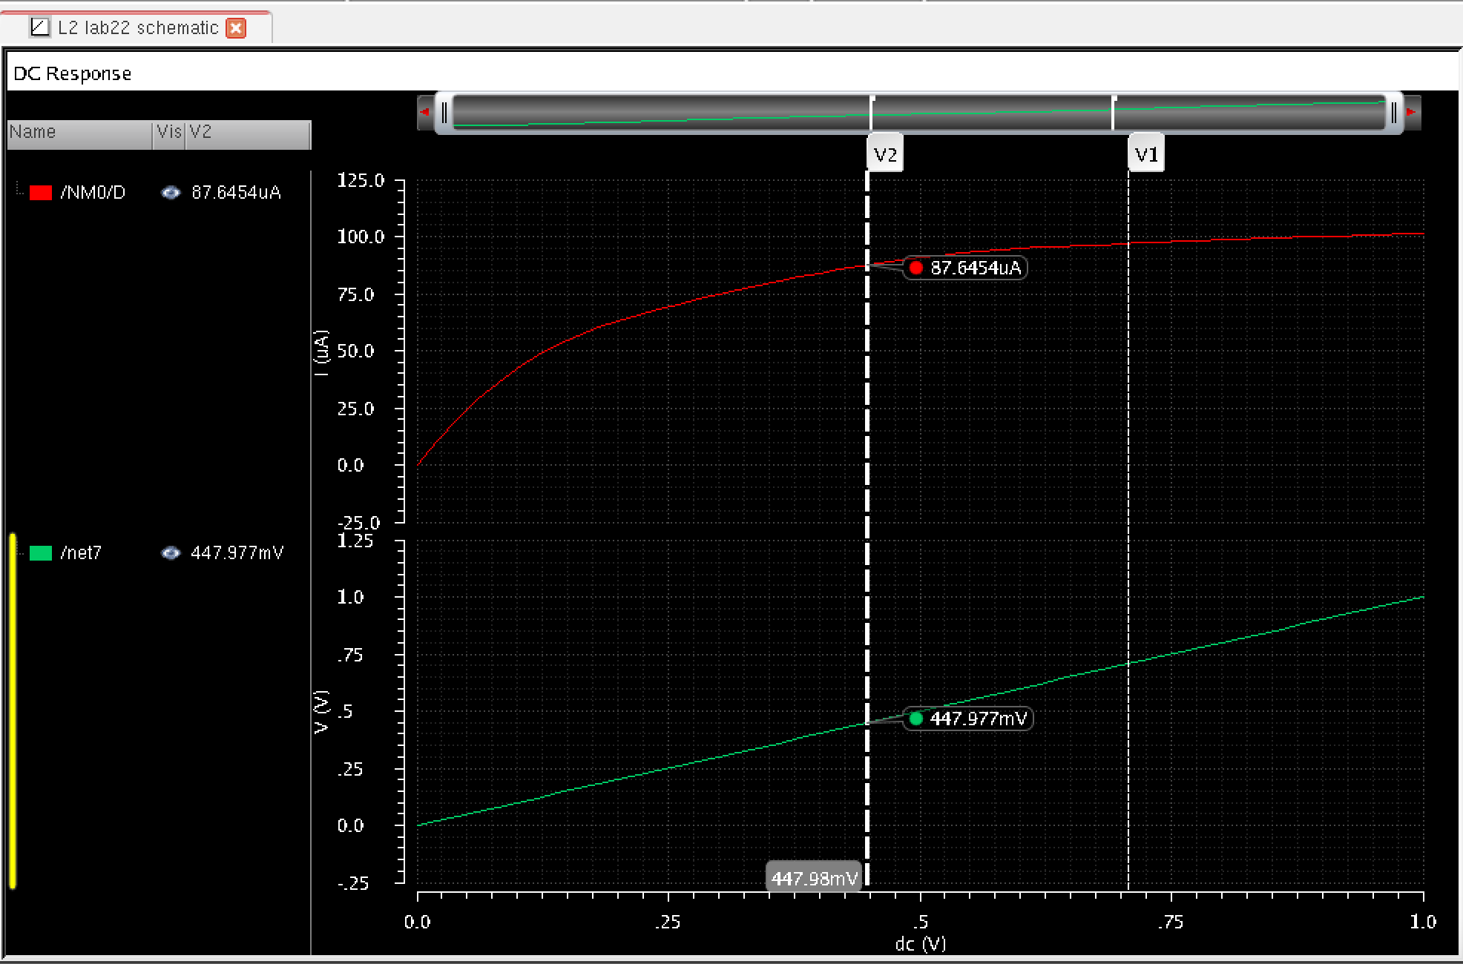

Conclusion: By applying the cascode mirror on to the circuit, we have noticed a huge change in nmosv1, were the current in voltage 1 and 2 increases tremendously through aplitude.

Question5.

Schematic3

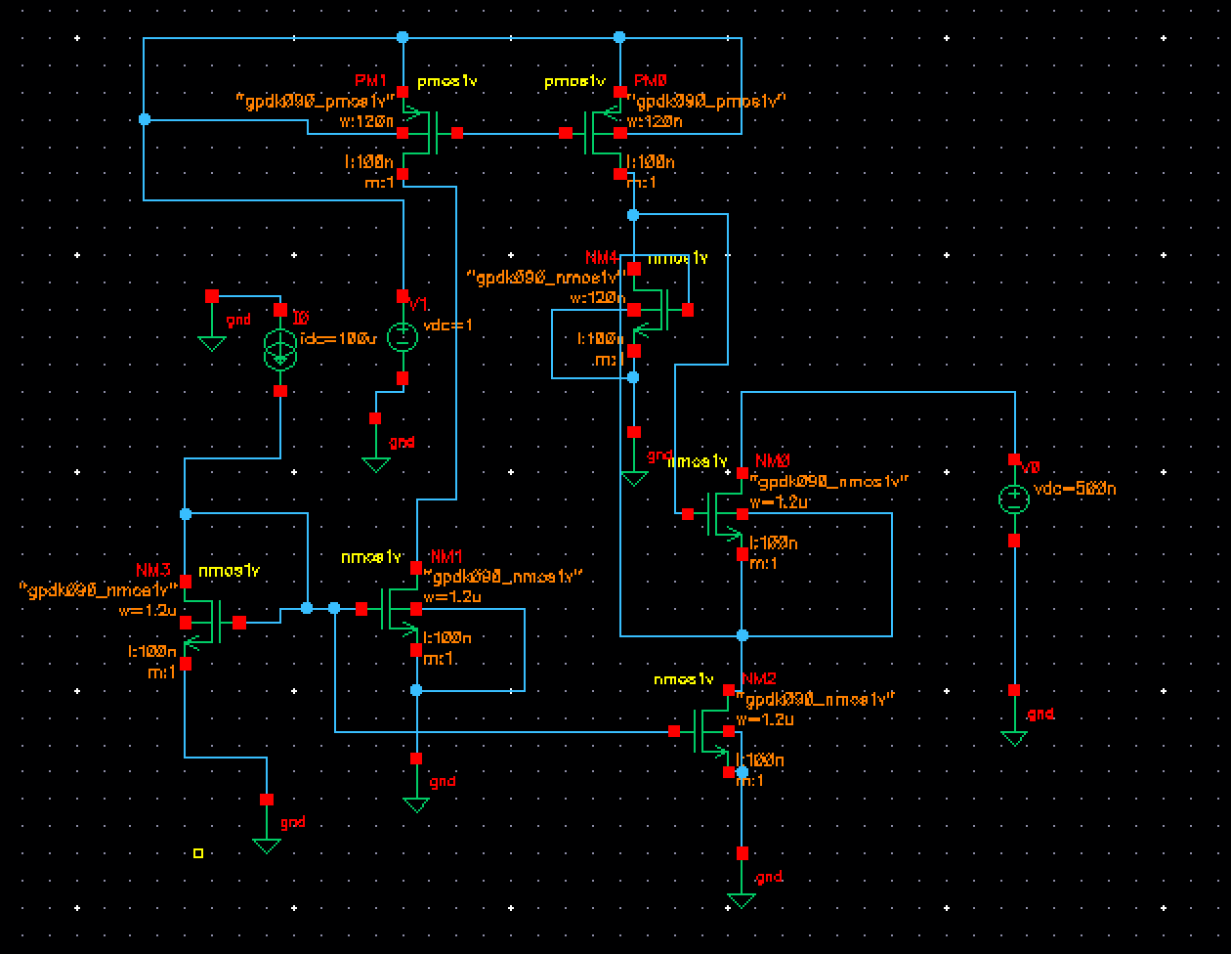



Conclusion: No result was found after applying the more transistors. This could be the result of a over drive or short circuiting by applying too much current.